Alexandre Dufresne-Nappert

20948586

Di = 0.1 m

Thickness is 0.001 m

Steps taken

1. Select 2D Axis Symetric

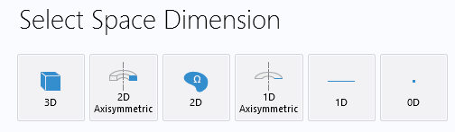

1. Select heat flow in Solids, liquids and laminar flow

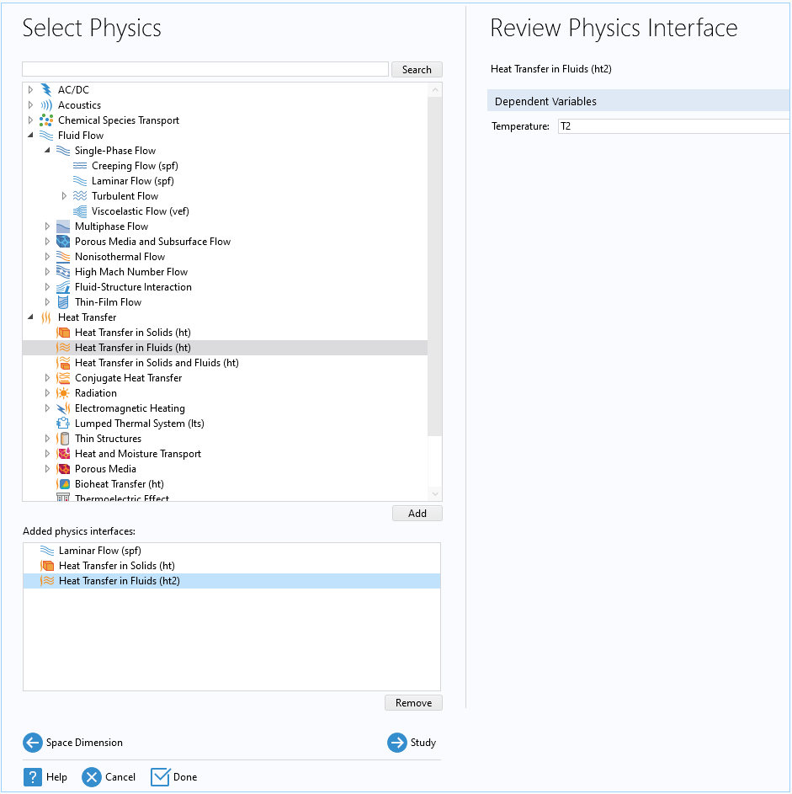

1. Select Stationary for steady state

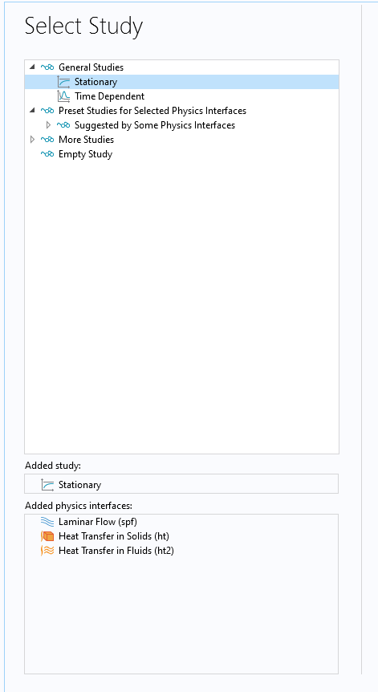

1. Start defining the materials and constants in the parameters

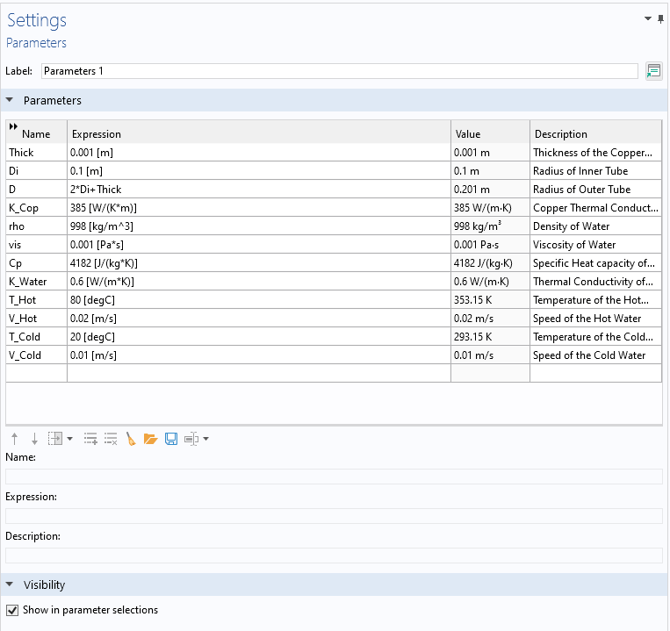

Geometry

Add the following 3 Objects as Geometry

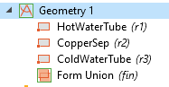

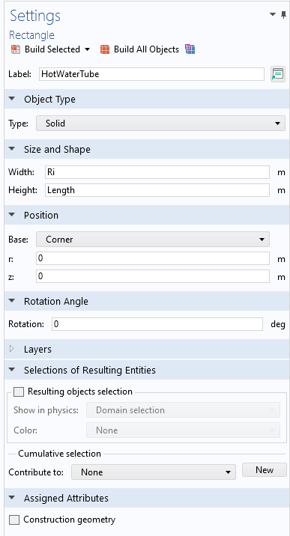

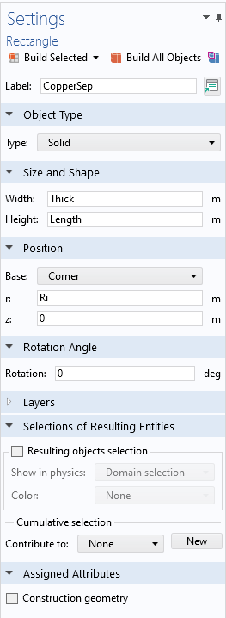

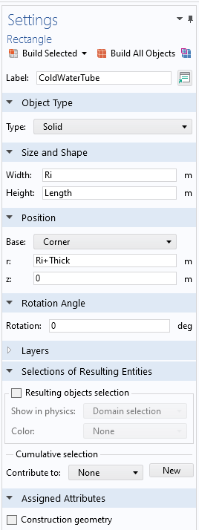

Now build everything

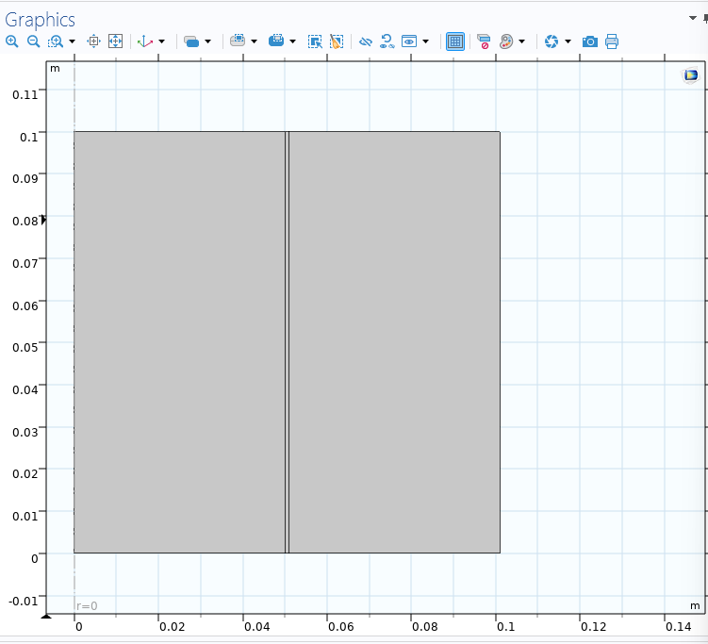

Laminar Flow Setup

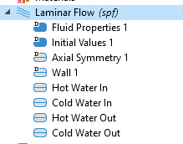

Click on the Laminar Flow Group / Folder and then click on objects to add and remove them from simulation

And now in the inlet, define the speeds

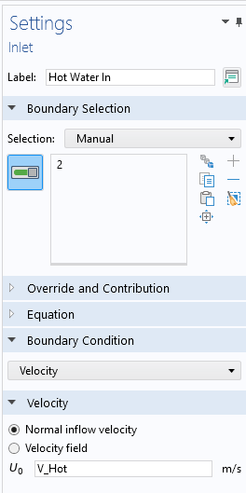

And for outlets, the pressure should be 0

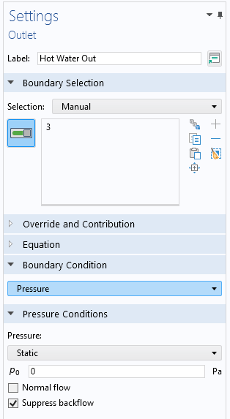

Otherwise nothing else should be touched

Answering Questions